Wildlife Tracker DB DESIGN AND RESTAPIs

Document

**Farheen Aslam**

# Introduction

## Purpose and scope

This document contains REST APIs exposed as a part of Wildlife Tracking Tool Application.

These APIs are used to perform the different operations to perform different operations to keep the track of animals over the period of time.

# DB DESIGN

## DB Design

The DB design used to implement the Wildlife Tracker Application

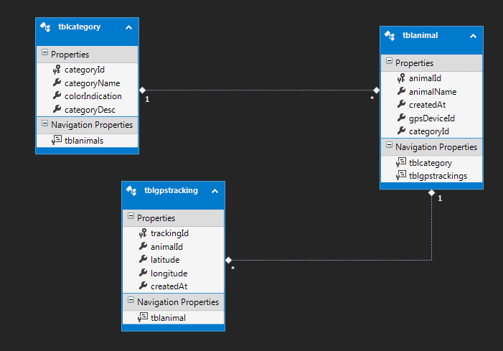

# REST APIs

## ADD NEW CATEGORY:

This API is used to add new category to the DB

**REQUEST URL : http://<servername>:<portNumber>/Services/CategoryService.svc/v1/AddNewCategory**

**METHOD:** POST

**REQUEST BODY** : {categoryName:"test", "colorIndication":"#8B0056", "categoryDesc":"Description"}

**RESPONSE :**

{

"message": " Successfully Created the category ",

"category": {

"categoryDesc": "This is to test",

"categoryId": 30,

"categoryName": " test ",

"colorIndication": "#8B0056"

},

"categoryList": null

}

## GET ALL CATEGORIES:

This API is used to get all the categories.

**REQUEST URL : http://<servername>:<portNumber>/Services/CategoryService.svc/v1/getCategories**

**METHOD:** GET

**RESPONSE :**

{

"category": null,

"categoryList": [{

"categoryDesc": "This is to test",

"categoryId": 30,

"categoryName": " test ",

"colorIndication": "#8B0056"

}]

}

## GET EACH CATEGORY DETAILS:

This API is used to get the details of each category when category id is specified.

**REQUEST URL : http://<servername>:<portNumber>/Services/CategoryService.svc/v1/categoryDetails/{categoryId}**

**METHOD:** GET

**RESPONSE :**

{

"message": "Fetching of categories",

"category": {

"categoryDesc": null,

"categoryId": 1,

"categoryName": "Giraffe",

"colorIndication": "#8B0056"

},

"categoryList": null

}

## UPDATE A CATEGORY:

This API is used to update a category

**REQUEST URL : http://<servername>:<portNumber>/Services/CategoryService.svc/v1/updateCategory/{categoryId}**

**METHOD:** PUT

**REQUEST BODY** : {"categoryId":"5", "categoryName":"Lion","colorIndication":"#8B0056", "categoryDesc":"This is to update"}

**RESPONSE :**

{

"message": "Successfully updated the category",

"category": {

"categoryDesc": "This is to update",

"categoryId": 5,

"categoryName": "Lion",

"colorIndication": "#8B0056"

},

"categoryList": null

}

## DELETE A CATEGORY:

This API is used to delete a category when category id is specified. It throws an Exception if there is no such category or if category is associated with an animal.

**REQUEST URL : http://<servername>:<portNumber>/Services/CategoryService.svc/v1/deleteCategory/{categoryId}**

**METHOD:** DELETE

**RESPONSE :**

{

"message": "Fetching of categories",

"category": {

"categoryDesc": null,

"categoryId": 1,

"categoryName": "Giraffe",

"colorIndication": "#8B0056"

},

"categoryList": null

}

## ADD NEW ANIMAL:

This API is used to add new animal to the DB

**REQUEST URL : http://<servername>:<portNumber>/Services/AnimalService.svc/v1/AddAnimal**

**METHOD:** POST

**REQUEST BODY :** {"categoryId":1,"gpsDeviceId":"TESTSERIALID","animalName":"Animal"}

**RESPONSE :**

{

"message": "Animal is allocated successfully",

"animal": {

"animalId": 24,

"animalName": "Animal",

"categoryId": 1,

"gpsDeviceId": "TESTSERIALID"

},

"animalList": null,

"totalAnimalDetails": null

}

## GET ALL ANIMALS:

This API is used to get all the animals.

**REQUEST URL : http://<servername>:<portNumber>/Services/AnimalService.svc/v1/getAllAnimals**

**METHOD:** GET

**RESPONSE :**

{

"animal": null,

"animalList": [

{

"animalId": 5,

"animalName": "UpdatedAnimals",

"categoryId": 1,

"createdAt": "/Date(1507636424000+0530)/",

"gpsDeviceId": "SERIAL1000934"

}]

}

## UPDATE AN ANIMAL:

This API is used to update an animal. It throws an Exception if the animal is not available.

**REQUEST URL : http://<servername>:<portNumber>/Services/AnimalService.svc/v1/updateAnimal**

**METHOD:** PUT

**REQUESTBODY**:{"animalId":5,"gpsDeviceId":"SERIAL1000934", "animalName":"UpdatedAnimals","categoryId": 1}

**RESPONSE :**

{

"message": "Animal is updated successfully",

"animal": {

"animalId": 5,

"animalName": "UpdatedAnimals",

"categoryId": 1,

"gpsDeviceId": "SERIAL1000934"

},

"animalList": null,

"totalAnimalDetails": null

}

## DELETE AN ANIMAL:

This API is used to delete an animal when animal id is specified. It throws an Exception if there is no such animal or if animal has already moved(there is a tracking information of the animal).

**REQUEST URL : http://<servername>:<portNumber>/Services/AnimalService.svc/v1/deleteAnimal/{animalId }**

**METHOD:** DELETE

**RESPONSE :**

{

"message": "Animal is deleted successfully",

"animal": {

"animalId": 24,

"animalName": "Animal",

"categoryId": 1,

"createdAt": "/Date(1507870211000+0530)/",

"gpsDeviceId": "TESTSERIALID"

},

"animalList": null,

"totalAnimalDetails": null

}

## GET ANIMALS COUNT PER CATEGORY:

This API is used to get the animals count per category and each category color..

**REQUEST URL : http://<servername>:<portNumber>/Services/CategoryService.svc/v1/getAnimalsPerCountPerCategory/{fromDate}/{toDate}**

**METHOD:** GET

**RESPONSE :**

{

"animal": null,

"animalList": null,

"totalAnimalDetails": [

{

"categoryId": 1,

"categoryName": "Giraffe",

"colorIndication": "#8B0056",

"totalAnimals": 2

},

{

"categoryId": 5,

"categoryName": "Lion",

"colorIndication": "#8B0056",

"totalAnimals": 1

}

]

}

## GET ALL ANIMALS LATEST POSITION:

This API is used to the latest positions of all the animals in all the category.

**REQUEST URL : http://<servername>:<portNumber>/Services/AnimalService.svc/v1/getAllAnimalsLatestLocation**

**METHOD:** GET

**RESPONSE :**

{

"gpsTrackingDetails": [

{

"animalId": 5,

"categoryId": 1,

"categoryName": "Giraffe",

"colorIndication": "#8B0056",

"createdAt": "/Date(1507711200000+0530)/",

"gpsDeviceId": "SERIAL1000934",

"latitude": -30.2555,

"longitude": 31.2556,

"trackingId": 14

}]

}

## GET ANIMALS LATEST POSITION PER CATEGORY:

This API is used to the latest positions of all the animals in selected category.

**REQUEST URL : http://<servername>:<portNumber>/Services/TrackingService.svc/v1/getEachCategoryAnimalsLatestLocation/{categoryId}**

**METHOD:** GET

**RESPONSE :**

{

"gpsTrackingDetails": [

{

"animalId": 7,

"animalName": "TestAnimal1",

"categoryId": 1,

"categoryName": "Giraffe",

"colorIndication": "#8B0056",

"createdAt": "/Date(1507710312000+0530)/",

"gpsDeviceId": "SERIAL10009355",

"latitude": -30.2555,

"longitude": 31.2555,

"trackingId": 7

}]

}

## ADD TRACKING INFO:

This API is used to simulate the movement of animals. Every time the API is called, the animal is considered to move and its location is stored in the DB. To test the animal, this API will be used to add the GPS location of each animal.

**REQUEST URL : http://<servername>:<portNumber>/Services/ TrackingService.svc/v1/ AddTrackingInfo**

**METHOD:** POST

**REQUEST BODY**:{ latitude":8.5241,"longitude":76.9366,"gpsDeviceId":"SerialTest2"}

**RESPONSE :**

{

"animalId": 16,

"createdAt": "/Date(1507870543308+0530)/",

"gpsDeviceId": "SerialTest2",

"latitude": 8.5241,

"longitude": 76.9366,

"trackingId": 17

}